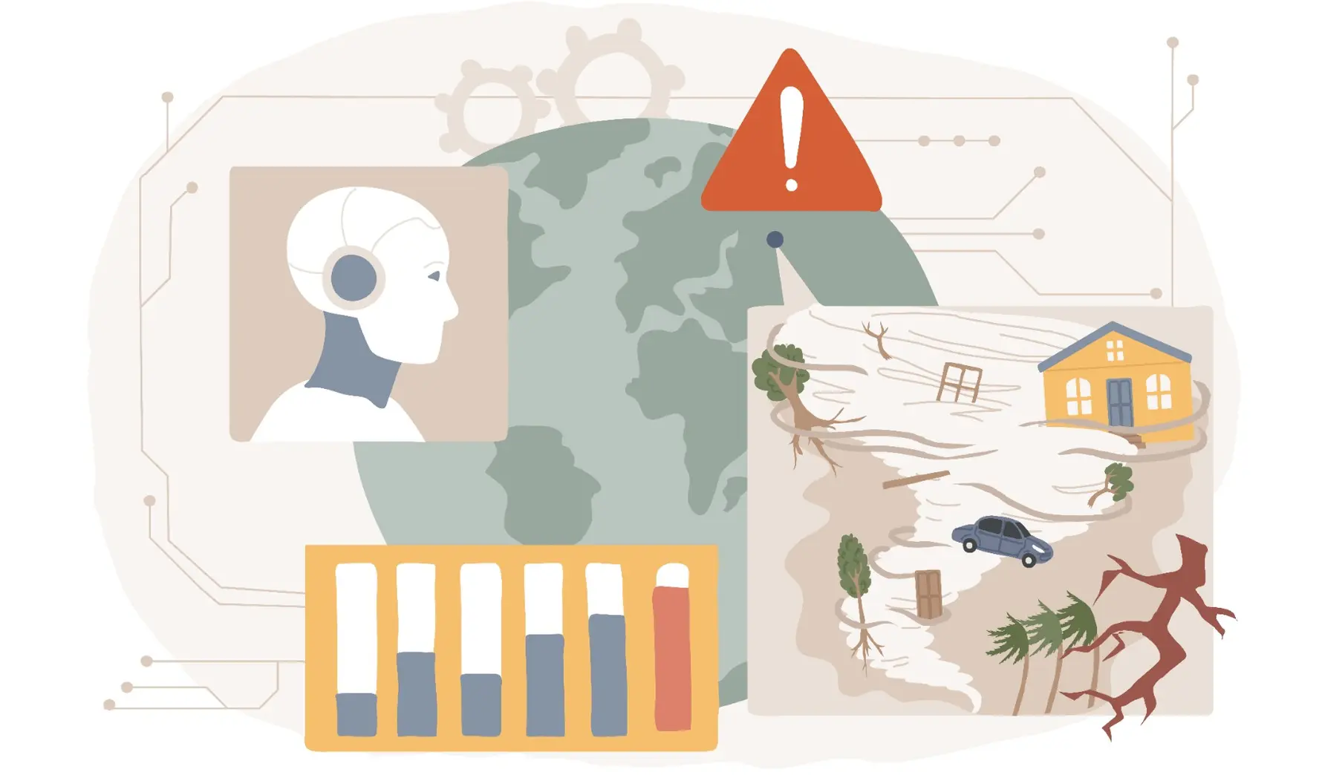
Crisis Help Classification
Multi-label classification of humanitarian needs in disaster messages
Slavova,Katerina K.S.
2025
Contents
What? 2
Why? 2
Who? 2
When? 3
How? 4

What?
The goal of this project is to develop an AI Crisis Help Classification system. The model will analyze crisis messages and predict the intent (request for help or an offer for help) and the humanitarian needs detected (shelter, water, food, medical help, rescue, etc.). The target is a set of binary labels for each message and because a single message can belong to multiple categories at the same time, the problem is described as a multi-label classification task. The aim of the system is to support emergency teams by helping them filter, prioritize and direct incoming messages to the appropriate teams during disasters.

Why?
During or immediately after a disaster occurs, people try to connect with disaster response organizations through direct or indirect communication. The emergency teams have to quickly identify the most important ones and redirect them to the specific organization that takes care of the specific problem. In these situations, every second is vital and properly handling every message is crucial. By automating part of this process through an AI system for crisis help classification, emergency teams will be able to filter, prioritize and direct messages more efficiently, giving them more time to respond to urgent situations.

Who?
- Emergency response teams, medical teams and rescue services
- Organizations such as “Red Cross” and “Doctors Without Borders”
- Academic Stakeholders: Roopali Gupta, Priyanka Darbari, John Litsenburg
- Project Developer: Katerina Slavova

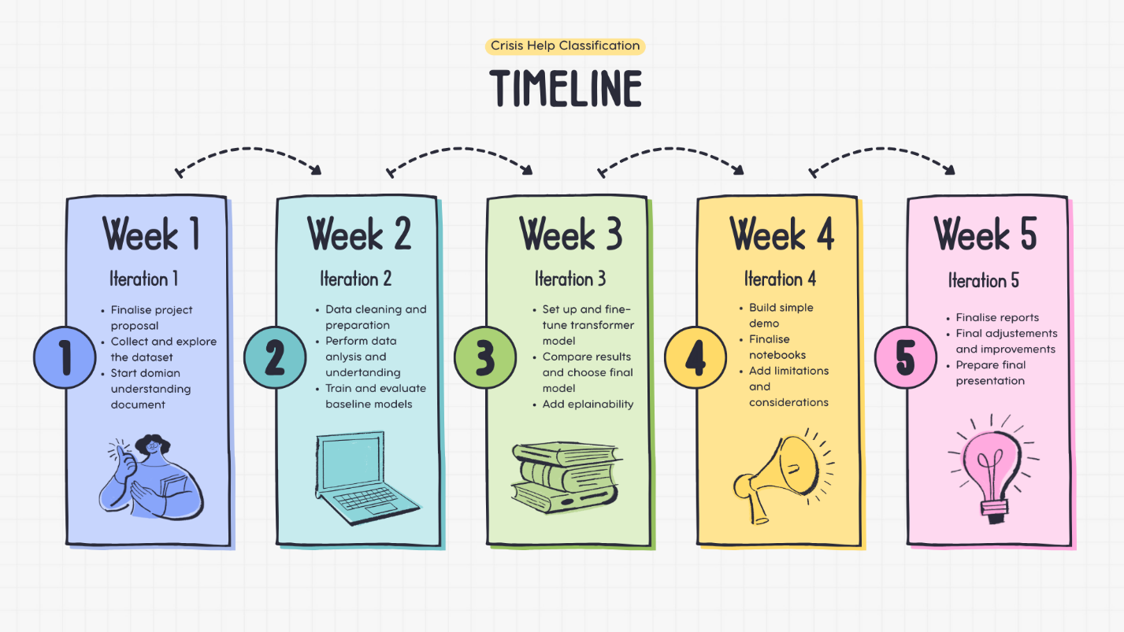
When?

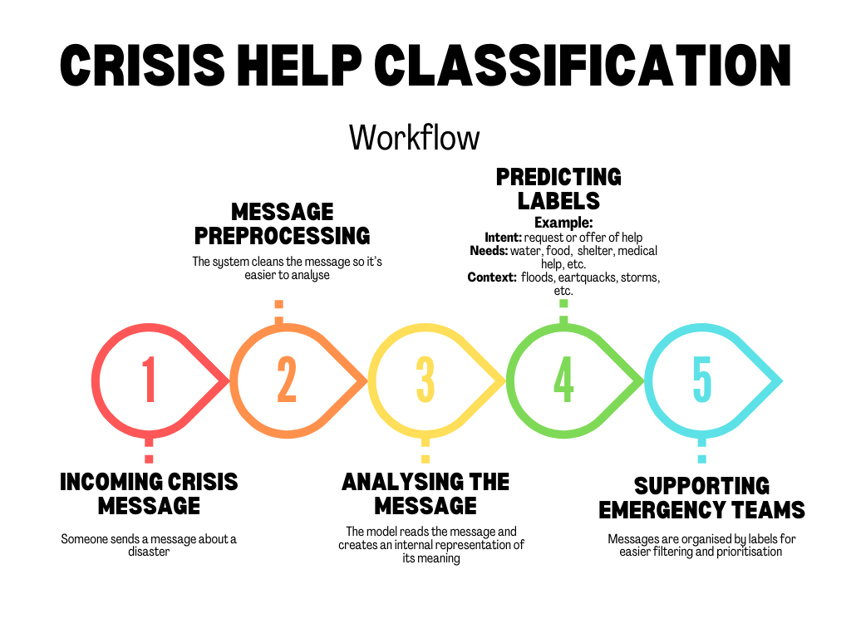
How?
First, the system will take a single crisis message as input. The message will be preprocessed in the same way during the training of the model. Then, the model will predict a vector of binary labels, where 1 is assigned if the category applies to the message and 0 is assigned for categories that do not apply. The system will output a set of labels describing the intent, needs and context of the message. As a final delivery, I will provide a simple demo, where the user can enter a message and see the predicted labels. The messages will be grouped by label. The complexity of the demo will depend on the available time.

